Press Release
FOR IMMEDIATE RELEASE

Title: Zeus Revolutionises Pallet Wrapping with the Launch of Innovative Apollo Pallet Wrapping System

Image:
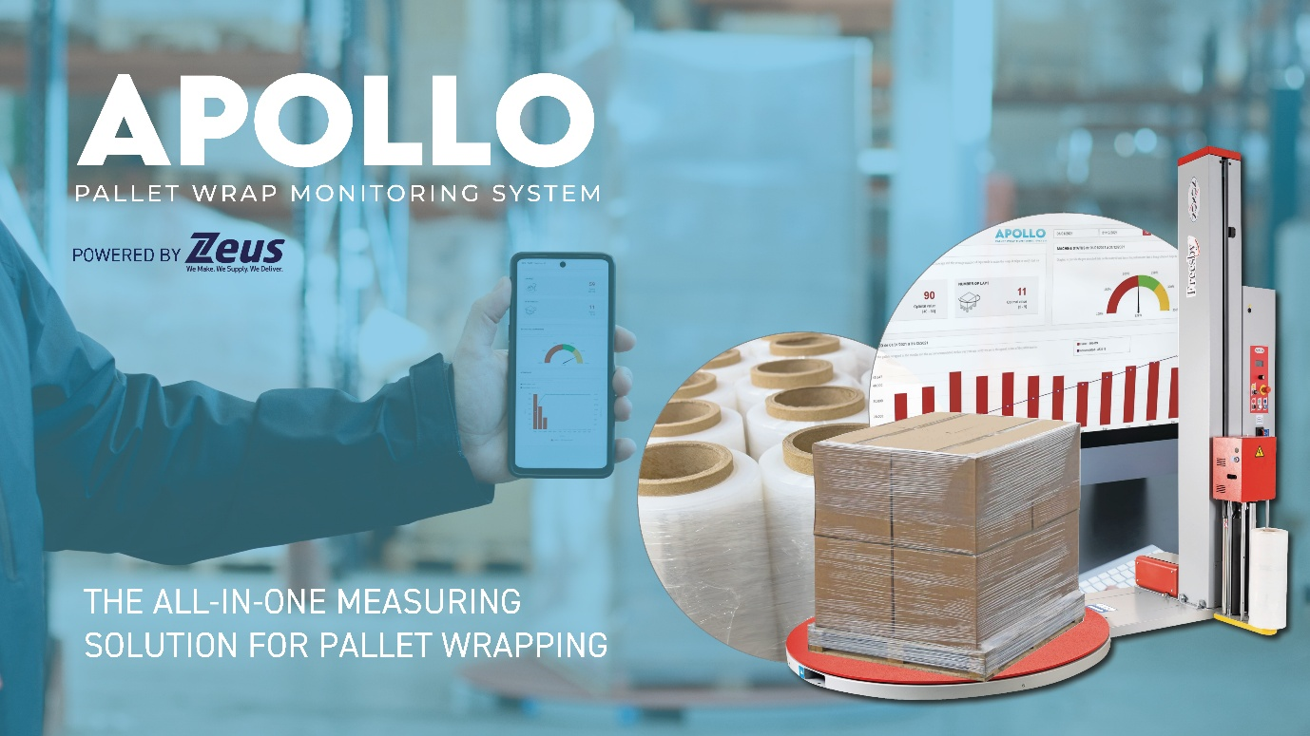

Text:

Zeus Packaging, a global leader in sustainable packaging solutions and a manufacturer of both pallet wrapping machinery and high-performance industrial application stretch films, proudly unveils the Apollo Pallet Wrapping System, a groundbreaking innovation set to transform the pallet wrapping industry. Guided by the mission of “saving the planet, one pallet at a time,” the Apollo Pallet Wrapping System underscores Zeus’ unwavering commitment to sustainability, efficiency, performance and innovation.

The Apollo System: A Game-Changer in Pallet Wrapping
Reducing plastic usage is no longer an option - it’s a responsibility. The Apollo Pallet Wrapping System is a revolutionary pallet wrap monitoring solution designed to reduce plastic consumption by up to 60%, saving time, cutting costs, and significantly reducing businesses' carbon footprint & Scope 3 Emissions. The Apollo Pallet Wrapping System digitally empowers businesses with real-time data on wrap usage, enabling informed decisions and optimised operations.

The system combines Hi-performance nano technology films manufactured by Zeus, a global agreement with Noxon on custom fit pallet wrapping machinery geared for high performance, fitted specific data collection sensors incorporated into the pallet wrapping machinery providing real time data into the Apollo monitoring software. The Apollo Pallet Wrapping System will not only cut costs, reduce plastic usage and waste, but also improve holding force stability, mitigating collapsing pallets.

Zeus are offering free audits to companies to show them exactly how much time and money and products could be saved by using The Apollo Pallet Wrapping System.
Key features of the Apollo Pallet Wrapping System include:
Real-time data tracking: Apollo allows you to monitor key metrics, including film net weight per pallet, real stretch wrap per pallet, meters used per pallet, pallets wrapped per roll, and the number of pallets produced during any requested period
Optimised efficiency and reduced waste: Apollo is designed to maximise wrapping efficiency and minimise waste, helping businesses improve operations while maintaining high standards of packaging performance. Their nano stretch film is proven to increase stretch up to 300%.
Integrated solution: The system comprises advanced machinery, user-friendly software, and Zeus-manufactured performance films. The only cost to the customer is the film they use!
“The Apollo Pallet Wrapping System represents a fundamental shift in pallet wrapping performance & sustainability,” said Keith Ockenden, CEO of Zeus Packaging Group. “By focusing on the true cost per pallet, we’re helping businesses balance cost-efficiency with environmental stewardship. The system was originally designed to highlight ‘Cheating’ that has gone on within our industry with businesses selling film by the kilo. We have seen so many poor practices that have short, delivered customers. The Apollo Pallet Wrapping System delivers 24/7 monitoring and enables date targeted continuous improvement. ”

A Vision for a Sustainable Future
Zeus’ Apollo Pallet Wrapping System is more than just a software - it’s a movement towards sustainable packaging. By embracing this eco-conscious solution, businesses can reduce the amount of plastic used and wasted, foster innovation, and take measurable steps toward a greener future.

Proven Success
A prominent UK/European retail sports brand first trialled the wrapping system and reported
“We faced many issues with our old wrapping systems from breaking parts, lack of adequate support, inefficient wrapping performance and creation of too much waste. Innovative features of Apollo system from Zeus caught our attention last year. Promising no capex costs, free servicing and support plus extra reporting capabilities we wanted to try it on. Nine months later and having now tested seven machines across two sites we are very satisfied with the results and are moving all of our pallet wrapping technology over to Apollo.
Thanks to Zeus’ expertise and efficient performance of Noxon machines we reduced our plastic waste by 40%. Reporting features of Apollo system provided accurate tracking of film usage data across all machines. This allowed effective stock planning of machine stretch. Our stretch before was 180-220%, our stretch with the Apollo system is now at 260% plus, reducing our film usage by 8.4 tonnes per annum. The support from Zeus has been exceptional with quick response rate, high engineer availability and willingness to help in all situations.”

Join the Movement
The Apollo System officially launches this January. For businesses ready to revolutionise their pallet wrapping processes and embrace sustainability whilst cutting costs, Apollo is the solution you’ve been waiting for. To schedule a free demonstration and audit of your plastic usage, contact:
apollosales@zeuspackaging.com or visit https://global.zeuspackaging.com/apollo-system/
Together, let’s redefine the future of packaging - one pallet at a time.

End of Release

For media inquiries or further information, please contact:

Pip Gorringe
Director of Marketing
Zeus Packaging
Pip.Gorringe@zeuspackaging.co.uk
07809737871

About Zeus Packaging
Zeus Packaging is a leading provider of sustainable packaging solutions, committed to innovation and excellence in serving a diverse range of industries. With a focus on sustainability and customer satisfaction, Zeus Packaging delivers high-quality, eco-friendly packaging products to clients worldwide. Serving in 38 countries and with 61 locations, Zeus truly is a global packaging solutions provider.

