**Press Release**

**Mr. Ashok Chaturvedi highlights the role of Artificial Intelligence in addressing the problem of flexible packaging waste at ElitePlus++Global Business Summit 2024**

**Delhi/Mumbai, September 30, 2024:** Mr. Ashok Chaturvedi, Founder, Chairman, and Managing Director, UFlex Group, delivered a pivotal keynote address highlighting the role of artificial intelligence in solving the problem of flexible packaging waste, contributing to a cleaner and greener planet, at the world’s largest business summit on flexible films and laminates for packaging and applications.

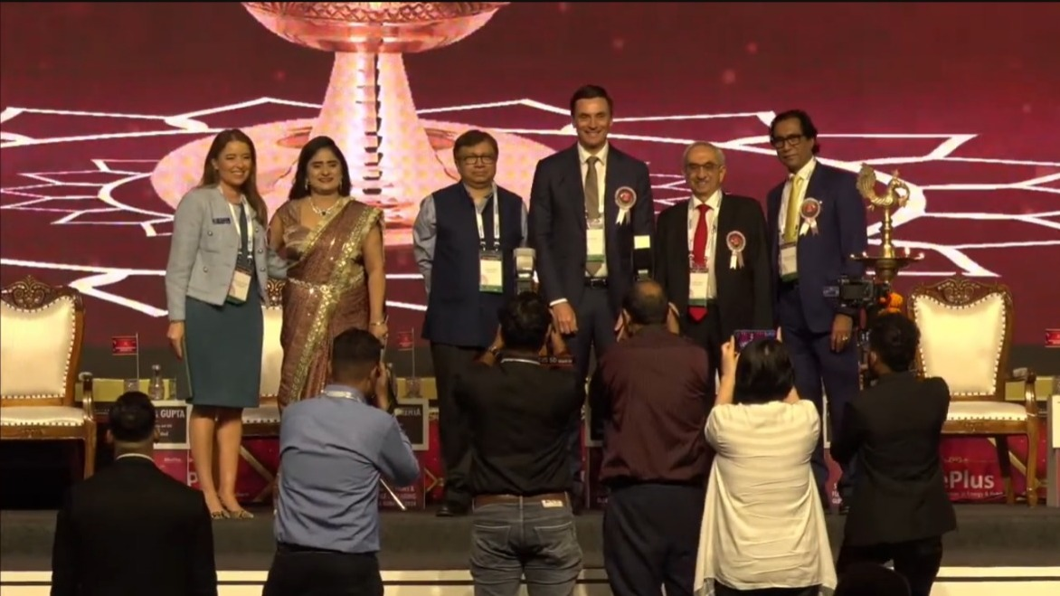

*L to R: Luciana Pellegrino, President, World Packaging Organization; Nidhi Verma, Founder & Managing Director, ElitePlus Business Services; Saugata Gupta, Managing Director & CEO, Marico Limited; Jacob Duer, President and Chief Executive Officer, Alliance to End Plastic Waste; Nadir Godrej, Chairman & Managing Director, Godrej Industries; and Ashok Chaturvedi, Founder, Chairman & Managing Director, UFlex Group, at ElitePlus++Global Business Summit 2024*

The flagship summit, being held today, September 30, 2024, through October 1, 2024, at the Reliance Jio World Convention Centre in Mumbai, India, featuring industry leaders, distinguished speakers, and delegates, from over 25 countries. The event encompasses in-depth discussions and presentations on pressing topics including the evolving global packaging landscape, social responsibility, brand strategies in the FMCG sector, and recycling for circularity, amongst others.

In his keynote, **Mr. Ashok Chaturvedi** presented an insightful overview of the genesis and remarkable evolution of flexible packaging and the significant impact of AI on managing the problem of flexible plastic waste. He stated, *“With a global population of 8 billion, we cannot ignore our reliance on flexible packaging, essential for delivering food, pharmaceutical, and other consumer products, while ensuring safety, durability, protection from contamination, safer transportation, and enhanced accessibility”.*

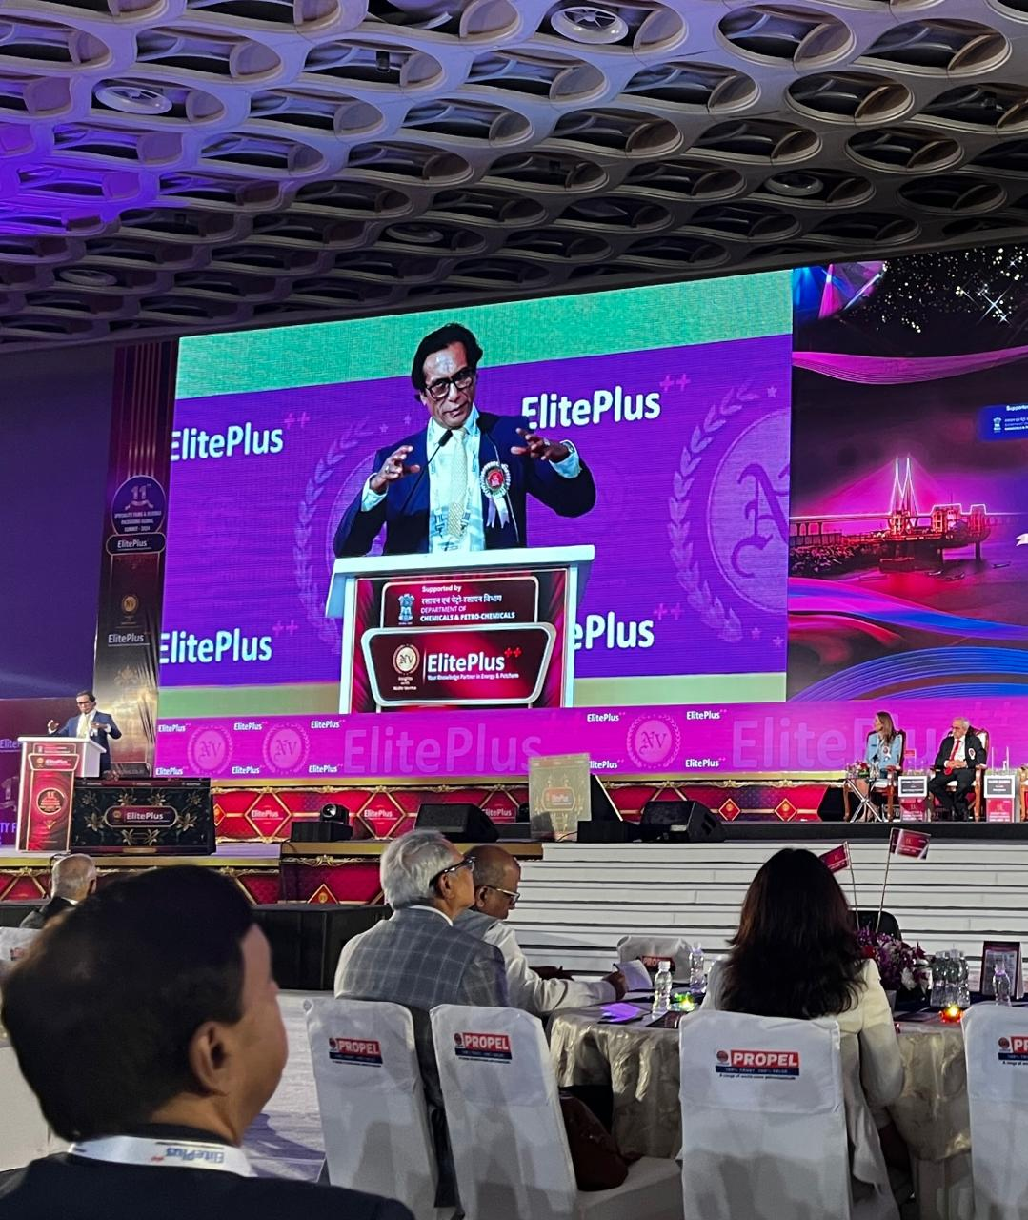 *Mr. Ashok Chaturvedi delivering a keynote address at ElitePlus++Global Business Summit 2024*

*“The need of the hour is to deploy advanced AI sorting technologies that will use sensors to separate food-grade from non-food-grade plastics. UFlex is making significant investments in these technologies, and we will be ready to showcase our MVP in the coming months. These advanced technologies will be integrated into our global recycling infrastructure, which spans India, Poland, and Mexico. We are the only company that is working within India and globally on innovative solutions in flexible MLP materials and PCR and its applications”,* he added.

*“By leveraging these AI technologies, we can enhance our recycling processes and contribute to a more sustainable future. The future of packaging lies in our ability to innovate sustainably and responsibly. We invite regulators, policymakers, brand owners, and other producers to witness this technology at our facilities in early 2025. We will be happy to collaborate with the industry to scale this and deliver on our Government’s EPR and sustainability goals”, he concluded.*

At the event, Mr. Jeevaraj G. Pillai, Director-Sustainability and President-Flexible Packaging and New Product Development, UFlex Limited, moderated an important panel discussion: Drivers, Challenges, and Barriers to Recycling: Is India Ready?

He shared insights into UFlex's sustainability initiatives, stating, *“Our commitment to sustainability is not just about compliance; it is about innovating solutions that make a real impact on the environment and propel a circular economy. We promote environmentally friendly processes, evaluate the effect of raw materials on the environment, and opt for lower-emission sourcing choices in flexible packaging. We are aligning our ESG targets with efforts to mitigate global warming and have initiated a strategy for carbon offsetting through community-based and biodiversity projects”.*

The summit also features specialized sessions focused on sustainability, including panel discussions that address the critical role of flexible packaging in green energy, as well as emerging film extrusion technologies and new developments. Distinguished speakers from the Ministry of Environment, Forest and Climate Change (MoEFCC), the Ministry of Chemicals and Fertilizers (MoCF), and the Department of Chemicals and Petrochemicals, will engage in discussions on aligning product development with circularity needs.

**For media queries, please contact:**

Corporate Communication | UFlex Limited | [corpcomm@uflexltd.com](mailto:corpcomm@uflexltd.com)

**About UFlex:**

UFlex is India’s largest multinational flexible packaging and solutions company. Since its inception in 1985, UFlex has grown from strength to strength and has built a strong presence across all verticals of the packaging value chain - packaging films, chemicals, aseptic liquid packaging, flexible packaging, holography, engineering, and printing cylinders.

With a 10,000+ strong multicultural workforce across global regions that works toward developing innovative, value-added, and sustainable packaging solutions, the company has earned an irreproachable reputation for defining the contours of the ‘Packaging Industry’ in India and overseas. It provides end-to-end solutions to numerous Fortune 500 clients across various sectors such as FMCG, consumer product goods, pharmaceuticals, building materials, automobiles, and more, in more than 150 countries.

Headquartered in Noida, the National Capital Region, India, UFlex enjoys a global reach with advanced manufacturing facilities in India, UAE, Mexico, Egypt, USA, Poland, CIS country, Nigeria, and Hungary.

A winner of various marquee global awards for product excellence, innovation, and sustainability, UFlex is the first company in the world to earn recognition at the Davos Recycle Forum in 1995 for conceptualizing the recycling of mixed plastic waste. For more details, please visit: [www.uflexltd.com](http://www.uflexltd.com)