Press release - November 2024

RoRo StretchPack® packaging machine
for JACKON Insulation by BEWI’s new site in Belgium

Tentoma A/S, a leading provider of automated packaging solutions, has installed a RoRo StretchPack® XL packaging machine at JACKON Insulation by BEWI’s newly inaugurated production facility in Olen, Belgium. This state-of-the-art packaging machine will play a vital role in the new production line, ensuring the XPS construction boards are delivered to construction sites in optimal condition.

The decision to invest in the RoRo StretchPack® technology aligns with JACKON Insulation by BEWI’s commitment to delivering high-quality construction boards. This innovative packaging solution ensures that their XPS construction boards are effectively protected against external contamination.

JACKON Insulation by BEWI has already experienced the advantages of the RoRo StretchPack® technology with another machine, which has consistently met their high standards for performance and reliability. The success of this installation has led JACKON Insulation by BEWI to invest in a second RoRo StretchPack® machine for their new production site in Belgium.

Six-sided packaging of pallets with XPS boards
The new RoRo StretchPack® XL machine is designed to package XPS construction boards stacked on pallets. The stacked XPS boards, including the pallet, are wrapped horizontally in a stretch hood film. The stretch hood film is welded at both ends during packaging, providing six-sided waterproof protection. This ensures the XPS boards maintain high quality and performance, remaining dry and intact throughout transport and storage.

“We are thrilled that JACKON Insulation by BEWI has chosen Tentoma once again for their packaging needs,” said Troels B. Mathiesen, CEO of Tentoma A/S. “Their continued trust in our RoRo StretchPack® technology underscores the reliability and efficiency of our solutions. We proudly support JACKON Insulation by BEWI and their commitment to delivering top-quality insulation products.”
Innovative and sustainable packaging solutions
RoRo StretchPack® technology is based on proven stretch hood packaging methods traditionally used for vertical hooding of pallets. Tentoma A/S has refined this technology for horizontal packaging, enabling both 4-sided and 6-sided packaging. This innovative approach is ideal for packaging rolls, building materials, and other large products. Compared to conventional methods like orbital wrapping and heat shrink, the stretch hood film used in RoRo StretchPack® machines significantly reduces film consumption by 25-60%.
For more information about RoRo StretchPack® packaging machines visit www.tentoma.com

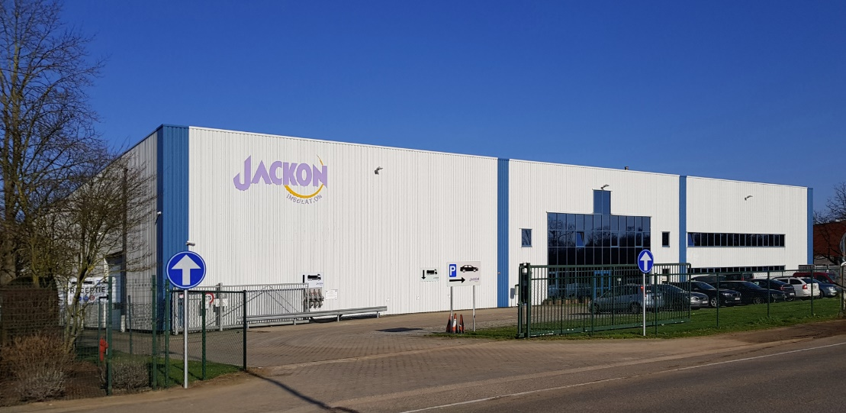
JACKON Insulation by BEWI’s new site in Olen, Belgium, where the new RoRo StretchPack® XL machine is installed.
(Photo: JACKON Insulation by BEWI)
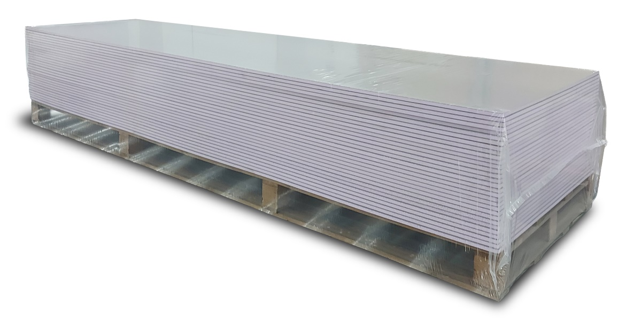
Six-sided packaging of building boards including the pallet using a stretch hood film and RoRo StretchPack® packaging. The stretch hood film is welded at both ends during packaging, providing six-sided waterproof protection.

For further questions please get in touch with Tentoma A/S: info@tentoma.com

