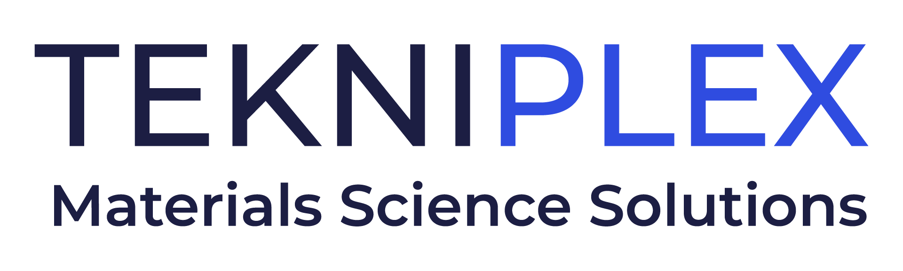
Press release

Media Contact: Peter Gavigan
TekniPlex
+1 (908) 720-5391
Peter.Gavigan@tekni-plex.com

Christopher Dale
Turchette Agency
+1 (973) 227-8080 ext. 116
cdale@turchette.com

TekniPlex Consumer Products Launches Dispensing Liners
Providing Dosing Moderation & Product Protection

Peel n Pour™ controls product flow while preventing leaks; in addition to liquids, solution can be used for powders, spices, and other solid products.

Wayne, PA – TekniPlex Consumer Products, a globally integrated provider of innovative solutions through materials science and manufacturing technologies, has introduced a range of dispensing liners whose convenient peel-tab design provides simplified dosing for a wide variety of liquid, powder, and solid products. An attractive alternative to conventional plastic press-in orifice reducers, TekniPlex Consumer Products’ new line of Peel n Pour™ solutions offer strong induction seals to prevent product leaks, with custom orifice sizes to reduce product flow by as much or as little as a brand owner specifies. The fully customizable peel-tabs allow for easy removal while maintaining tamper-evidence and product spoilage.

TekniPlex Consumer Products’ new Peel n Pour™ solutions are ideal for a broad array of products in which product flow control is useful – everything from baby oils and personal care products to cosmetics, household items, automotive, and even pharmaceutical applications. Liquids, powders, flaky goods such as spices, and oral solid dose items like pills or gummy vitamins can all benefit from both flow control and leak prevention with the added benefit of a hermetic seal.

Peel n Pour™ enjoys exemplary sealing capabilities for all bottle types and substrates – including HDPE, PP, PET, and glass constructions – and are printable for enhanced brand aesthetics. Notably, eliminating the need for separate plastic orifice reducers also allows brand owners to reduce production costs and simplify sourcing demands, an appealing “addition by subtraction” benefit.

“Controlling product flow can be an overlooked benefit whose value is important because it significantly impacts consumer product experiences,” DeAnn Umland, Vice President & General Manager, Integrated Performance Solutions, Americas, TeknixPlex Consumer Products. “The ability to dispense only the desired amount of high-leverage products reassures consumers that they are less likely to waste product and more likely to keep the remaining product free of contaminants. How consumers use a product is a crucial aspect of its overall success, and Peel n Pour’s dual benefits of dosing and leak prevention can tangibly heighten consumer experiences.”

# # #

About TekniPlex Consumer Products
TekniPlex Consumer Products specializes in advanced materials science solutions for companies in the food & beverage and CPG industries with a focus on protecting products, strengthening brands, and innovating sustainably. TekniPlex Consumer Products serves companies around the world in sectors including beauty and personal care, household items, and food and beverage.
With an expanding selection of material-diverse solutions – bolstered in recent years, by a series of strategic acquisitions – TekniPlex Consumer Products is leading the way creating next-generation packaging designs that address real-world challenges in the markets it serves. Most notably, the company is focused on developing more sustainable solutions that continue to provide product safety and consumer satisfaction. For more information, visit www.tekni-plex.com/consumer

