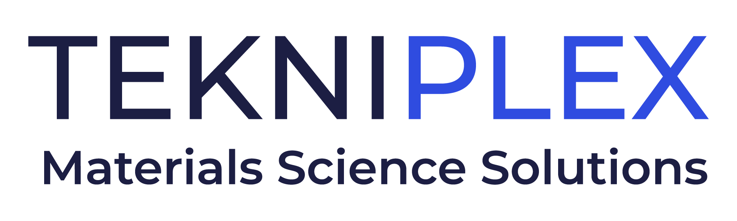
Press release

Media Contact: Peter Gavigan, TekniPlex
+1 (908) 720-5391, Peter.Gavigan@tekni-plex.com

Christopher Dale, Turchette Agency
+1 (973) 227-8080 ext. 116, cdale@turchette.com

At Pack Expo 2024, TekniPlex Consumer Products
to Showcase Recyclable Container Liners and Tout New U.S.
Molded Fiber Production Facility, Among Other Highlights

Wide array of sustainability-minded solutions
and integrated components on display at Booth W-21047.

Wayne, PA – TekniPlex Consumer Products, a globally integrated provider of innovative solutions through materials science and manufacturing technologies, will highlight a variety of recent sustainability-minded solutions and expansions at Pack Expo 2024, November 3-6 in Chicago. At its Booth W-21047, the company will showcase solutions for a broad array of applications, from value-added liners for jars and bottles in the food and nutrition sectors to key components for a wide swath of packaging formats. Experts also will be on hand to discuss TekniPlex Consumer Products’ latest U.S. manufacturing plant, which opened just this month.

Many of the solutions TekniPlex Consumer Products will highlight at Pack Expo comprise a range of potential materials to help costumers transition to more sustainability-minded substrates without sacrificing performance and functionality. Called the company’s “Sustainability AND” approach, the mindset has led to successful sustainability initiatives in several sectors, including F&B niches such as dairy, protein, eggs and shelf-stable products.

Recyclable Paper-based Liners
Earlier this year, TekniPlex Consumer Products introduced a paper-based liner recyclable wherever paper recycling streams are available, and compatible with conventional induction heat sealing equipment. The company’s ProTecSeals® Recyclable IHS Liners are suitable for a wide range of bottles and jars, making them ideal for vitamins, supplements, protein powders, peanut butter and other non-reactive, non-acidic dry products.

ProTecSeals® liners are recyclable in the mixed paper recycling stream – proven by passing a reputable third-party testing protocol for re-pulpability and recyclability – while providing the same protective properties as conventional liners. ProTecSeals® Recyclable IHS Liners have moisture and oxygen barrier, leak resistance, contaminant prevention and shelf-life extension equal to a standard IHS liner. Printed recycling instructions on the liner can be supplemented or replaced with brand messaging, adding real estate for under-the-cap marketing opportunities.

North American Manufacturing Expansion
Among the recent news TekniPlex Consumer Products brings to Pack Expo is the October opening of a 200,000-square-foot facility dedicated to the molded fiber solutions sector in northwest Ohio. Representing TekniPlex Consumer Products’ eighth specialty molded fiber manufacturing plant, the facility further expands capacity and capabilities in this fast-growing, sustainability-minded niche. Among the novel technologies featured at the plant will be a proprietary fiber production process allowing for stronger, better-quality final products with enhanced protective properties – a differentiator particularly in the egg carton space, but also for several other food categories.

The Ohio plant signifies TekniPlex Consumer Products’ intentions to continue expanding its portfolio not only in specialty molded fiber but other sustainability-minded materials – especially those comprising significant amounts of post-consumer recycled (PCR) content, or composed of more recyclable resins like polyethylene terephthalate (PET). In the broader dairy and shelf stable segments, TekniPlex Consumer Products also has assisted customers in lightweighting packaging, as well as transitioning from conventional polystyrene to alternative solutions incorporating polypropylene, PET or paper.

Innovations in Protein Processing Trays
At Pack Expo, the company also will highlight its recent successes in the protein processor tray segment. As it continues to expand its GeoPack range of sustainability-minded products, the company has introduced a protein tray officially designated as biodegradable in industrial compost settings. Recognized by the Biodegradable Products Institute, the tray is composed of cellulose-based direct food-contact material, and is manufactured in the United States. The new trays are part of far-reaching efforts to help customers transition from traditional foam polystyrene to more sustainable substrates like PET or foam polypropylene.

Integrated Performance Solutions
TekniPlex Consumer Products also features a roster of integrated performance solutions that help elevate overall packaging appearance, performance and sustainability. In addition to the aforementioned liner solutions, items on display at Pack Expo will include best-in-class gaskets for peak aerosol performance and durability; and plastic dip tubes manufactured with post-consumer recycled content, allowing brands to reinforce sustainability commitments.

# # #

About TekniPlex Consumer Products
TekniPlex Consumer Products specializes in advanced materials science solutions for companies in the food & beverage and CPG industries with a focus on protecting products, strengthening brands, and innovating sustainably. TekniPlex Consumer Products serves companies around the world in sectors including beauty and personal care, household items, and food & beverage.

With an expanding selection of material-diverse solutions – bolstered in recent years, by a series of strategic acquisitions – TekniPlex Consumer Products is leading the way creating next-generation packaging designs that address real-world challenges in the markets it serves. Most notably, the company is focused on developing more sustainable solutions that continue to provide product safety and consumer satisfaction. For more information, visit www.tekni-plex.com/consumer.

