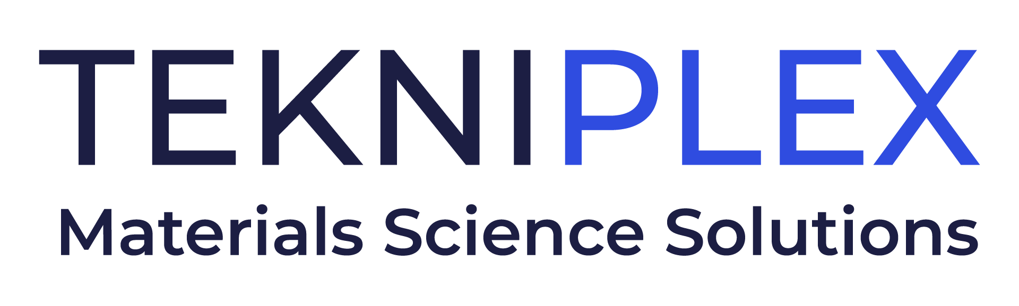
Press release

Media Contact: Peter Gavigan
TekniPlex
+1 (908) 720-5391
Peter.Gavigan@tekni-plex.com

Christopher Dale
Turchette Agency
+1 (973) 227-8080 ext. 116
cdale@turchette.com

At Paris Packaging Week, TekniPlex Consumer Products
to Showcase More Sustainable Aerosol Gaskets,
Dip Tubes, Liners, and Other Solutions

Highlights include recyclable outer gaskets for aerosol products, dip tubes made of post-consumer recycled material, and convenient new EdgePull® liner.

Wayne, PA – TekniPlex Consumer Products, a globally integrated provider of innovative solutions through materials science and manufacturing technologies, will place sustainable packaging innovations at the forefront of its presence at the Aerosol & Dispensing Forum, January 17-18, 2024, during Paris Packaging Week. At its Stand S40, the company’s offerings will range from recyclable outer gaskets, PCR-derived dip tubes, and easy-open liners to lightweight liners and PFAS-free polyolefin tubes.

Recyclable in geographies where thermoplastic elastomer (TPE) recycling streams are available, the company’s new range of outer gaskets for water-sensitive aerosol products are a novel TPE alternative to traditional rubber outer gaskets. This solution offers increased water vapor resistance compared with standard nitrile constructions, providing reduced waste through superior product protection. Suitable for products in a wide array of markets, the gaskets assemble and adhere seamlessly on mounting cups for simplified manufacturing.

Another solution will be dip tubes derived from post-consumer recycled (PCR) materials. An attractive alternative to virgin plastic dip tubes, the PCR components are suitable for both pressurized and non-pressurized pump packaging. A means of improving sustainability without affecting product performance, the tubes are available in a low-density polyethylene (LDPE), a high-density polyethylene (HDPE), and a polypropylene (PP) versions.

Also at ADF, TekniPlex Consumer Products will showcase a new series of tabbed container liners combining easier opening with exemplary product protection, as well as optimized shelf life for reduced product waste. Now manufactured in Europe and India in addition to the United States, EdgePull® is compatible with a broad array of containers, making them ideal for product categories ranging from food & beverage and cosmetics to pharmaceuticals and nutrition. TekniPlex Consumer Products also offers a range of lightweight liners whose reduced density minimizes materials use and overall carbon footprint.

Finally, at ADF TekniPlex Consumer Products will display and discuss its PFAS-free polyolefin tubing, which is available both spooled and pre-cut. The company’s ability to offer this product derivative gives customers a viable alternative as regulatory requirements for packaging used in food, cosmetic, and personal care products are driving the need for these alternate material solutions. PFAS-free tubing provides an alternative today, well ahead of any required phaseouts.

“Our ‘Sustainability And’ philosophy helps us consider both the environment and product functionality in everything we do,” said Eldon Schaffer, CEO of TekniPlex Consumer Products. “Always, our goal is to further sustainability while also improving performance across various parameters, including product protection, shelf life extension, cost-competitiveness, and consumer convenience. Whether enhanced sustainability comes from more recyclable materials, components derived from PCR, reduced product waste, or lightweighting, we’re committed to considering environmental impact and carbon footprint in everything we do.”

# # #

About TekniPlex Consumer Products
TekniPlex Consumer Products specializes in advanced materials science solutions for companies in the food & beverage and CPG industries with a focus on protecting products, strengthening brands, and innovating sustainably. TekniPlex Consumer Products serves companies around the world in sectors including beauty and personal care, household items, and food & beverage.

With an expanding selection of material-diverse solutions – bolstered in recent years, by a series of strategic acquisitions – TekniPlex Consumer Products is leading the way creating next-generation packaging designs that address real-world challenges in the markets it serves. Most notably, the company is focused on developing more sustainable solutions that continue to provide product safety and consumer satisfaction. For more information, visit www.tekni-plex.com/consumer

