Press release

Media Contact: Peter Gavigan
TekniPlex
+1 (908) 720-5391
Peter.Gavigan@tekni-plex.com

Christopher Dale
Turchette Agency
+1 (973) 227-8080 ext. 116
cdale@turchette.com

TekniPlex Healthcare Celebrates Costa Rica
Facility Expansion with Ribbon-Cutting Event

55,000-sq-ft expansion includes new medical tubing extrusion equipment,
as well as additional room for warehousing and assembly operations.

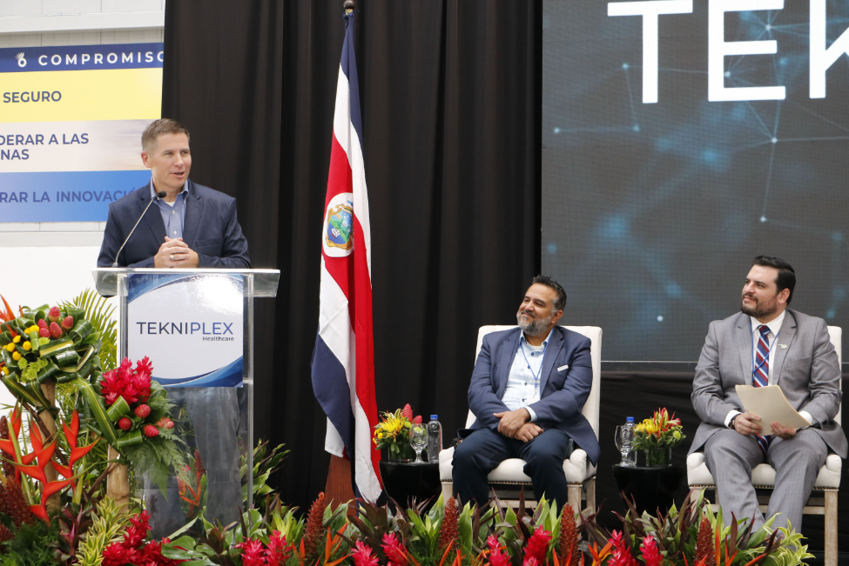
Wayne, PA – TekniPlex Healthcare, which utilizes advanced materials science expertise to help deliver better patient outcomes, celebrated the recent expansion of its production facility in Cartago, Costa Rica. Comprising 55,000 square feet, the additional room is being utilized for new medical tubing extrusion lines, downstream equipment for assembly and other operations, and warehousing space.

For TekniPlex Healthcare’s Cartago facility, the October 26 ribbon-cutting commemorated the third stage of a multiphase expansion. For this phase, a new building allows manufacturing to be segregated from warehousing, and provides additional capacity for both. Highlights to date include new medical tubing extrusion equipment installed in a cleanroom environment; the continuous closed-loop feedback extrusion system will help drive tighter tolerances at high manufacturing speeds, allowing TekniPlex Healthcare to increase its medical tubing and profile capacity amid a growing medical device components market.

The Phase 3 expansion also helps further improve TekniPlex Healthcare’s business continuity capabilities – often a key factor in strategic partner selection where dual validation is critical – by building upon existing medical tubing manufacturing operations in the United States, Mexico, Europe and China.

For TekniPlex Healthcare, the investment and expansion at its Cartago plant further extends its ability to produce and deliver complex medical device assemblies that meet and exceed stringent requirements. Upon completion, the project will add new extrusion lines, essentially doubling TekniPlex Healthcare’s capacity for micro-extrusions, quad tubes, thermally bonded paratubing, and advanced multilayer coextrusions for complex drug delivery applications. It will also include a dedicated cleanroom to perform other value-added activities and assembly.

# # #

About TekniPlex Healthcare
TekniPlex Healthcare utilizes advanced materials science expertise and technologies to develop and deliver critical solutions for medical and diagnostic devices, drug delivery systems and healthcare packaging applications. With a global reach, the division’s deep understanding of the greater pharmaceuticals and medical landscape helps it produce exemplary barrier properties for drugs and precision medical devices for interventional and therapeutic procedures. TekniPlex Healthcare’s ever-evolving portfolio helps meet demands for high-leverage medicines and mission-critical healthcare products that benefit care providers and patients. For more information visit www.tekni-plex.com/healthcare.

