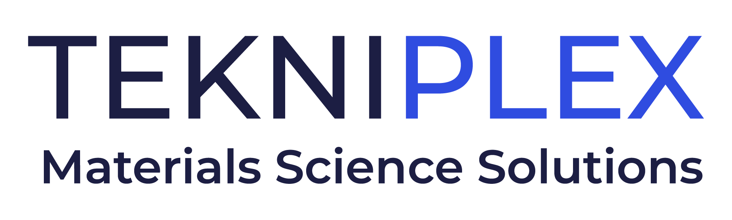
Press release

Media Contact: Peter Gavigan
TekniPlex
+1 (908) 720-5391
Peter.Gavigan@tekni-plex.com

Christopher Dale
Turchette Agency
+1 (973) 227-8080 ext. 116
cdale@turchette.com

At CPHI Barcelona, TekniPlex Healthcare to Highlight
Automatic Filler-Sealer for Single-Dose Plastic Vials

New Pentafill® A25 Filling & Sealing Machine offers improved sterility and high output in compact footprint; company also will showcase pharmaceutical-grade rubber formulations, as well as transparent Sustainable Blister Package system.

Wayne, PA – TekniPlex Healthcare, which utilizes advanced materials science expertise to help deliver better patient outcomes, will tout its recently incorporated next-generation filling and sealing machine for plastic containers at CPHI Barcelona, October 24-26. At Booth 2G19, the company will highlight the Pentafill® A25 Filling & Sealing Machine, which offers several improvements over previous models, including improved sterility and a smaller footprint.

TekniPlex Healthcare’s introduction of the updated PentafIll® A25 filling and sealing machine brings several advantages over its predecessor. In addition to the enhanced sterility afforded by fully automatic mechanisms, the machine does not require preheating with hot air, significantly mitigating any risk of compromising the filled product. The unit also has no central machine support, allowing for unobstructed laminar flow. Capable of producing up to 25 five-vial strips (125 vials total) per minute, the versatile unit is suitable for filling a wide range of viscosities for applications serving the pharmaceutical, diagnostics, nutraceuticals and animal health markets.

“As we expand our global presence in the pharmaceutical packaging market, we’re listening to our customers’ needs and innovating accordingly,” said Bryan Wesselmann, VP of Sales and Marketing for TekniPlex Healthcare. “Our customers expressed a need for improved sterility and the minimization of potential product contamination while filling, and the Pentafill® design team delivered.”

Also at CPHI, TekniPlex Healthcare will showcase one of its most notable recent sustainability breakthroughs: the world’s first fully transparent recyclable mid-barrier blister package. Recyclable in geographies where the #5 (polypropylene) recycling stream is available, the mid-barrier blisters feature a polyolefin blister film paired with a barrier PP lidding film. This marks the first time a formed blister + lidding combination is certified as recyclable– a significant milestone in the evolving push to make healthcare packaging more sustainable. TekniPlex Healthcare also will exhibit a fully recyclable polyester mono-material blister + lidding combination, suitable for products that do not require barrier protection.

TekniPlex Healthcare also will be highlighting its Flexapharm® SBC series of PVDC (polyvinylidene chloride) coated PVC structures, which offer exemplary barrier against oxygen and moisture. Also on display will be an array of Aclar® laminates designed to preserve the efficacy and shelf life of drugs with demanding environmental protection requirements.

Finally, TekniPlex Healthcare will exhibit examples of its pharma rubber compounding and manufacturing solutions for healthcare applications, including gaskets and closures. Manufactured to precise dimensional tolerances to ensure proper fit and function within packaging or medical devices, the company’s pharma-grade rubber substantially minimizes the risk of migration-associated impurities like extractables and leachables. In addition, TekniPlex’s modern laboratories enable development and testing of unique rubber solutions for customer-specific applications.

# # #

About TekniPlex Healthcare
TekniPlex Healthcare utilizes advanced materials science expertise and technologies to develop and deliver critical solutions for medical and diagnostic devices, drug delivery systems and healthcare packaging applications. With a global reach, the division’s deep understanding of the greater pharmaceuticals and medical landscape helps it produce exemplary barrier properties for drugs and precision medical devices for interventional and therapeutic procedures. TekniPlex Healthcare’s ever-evolving portfolio helps meet demands for high-leverage medicines and mission-critical healthcare products that benefit care providers and patients. For more information visit www.tekni-plex.com/healthcare.

