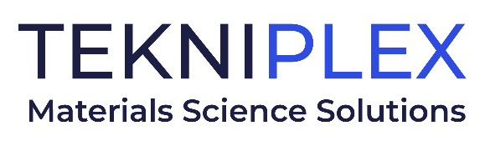
Press release

Media Contact: Peter Gavigan
TekniPlex
+1 (908) 720-5391
Peter.Gavigan@tekni-plex.com

Christopher Dale
Turchette Agency
+1 (973) 227-8080 ext. 116
cdale@turchette.com

TekniPlex Rebrands, Streamlining Corporate Identity

All legacy business unit brands transitioning to uniformly aligned corporate image, further strengthening TekniPlex’s presence in various sectors.

September 8, 2022 Wayne, PA – TekniPlex, a leading materials science solutions partner, has announced a comprehensive rebrand intended to streamline its corporate identity and further leverage its broad name recognition.

The global effort comes as TekniPlex is in the midst of unprecedented growth. With 15 acquisitions in the last five years, the company has effectively doubled in size. This growth culminated in a recent reorganization of its lines of business into two primary divisions: TekniPlex Healthcare and TekniPlex Consumer Products. The rebrand is the next market-facing step in this evolution.

“By consolidating all brands under the TekniPlex name, we will be able to better service our customers by providing them greater visibility into the full-breadth of our capabilities and offerings,” said Brenda Chamulak, President & CEO of TekniPlex. “We will also be able to more thoroughly leverage the synergies between our businesses, and solidify our position as a leading materials science solutions partner to many of the world’s largest brands.”

The updated brand structure unites all business units under two divisions -- Healthcare and Consumer Products. Previous business unit brand names will no longer be used in market-facing environments. The transition to a more uniform market presence will take place over time.

Uniting under the TekniPlex Healthcare division brand are legacy business units Colorite, Natvar, Dunn, JPG, TekniPlex Flexibles, TekniFilms, TekniPlex Europe, TekniPlex Gallazzi, Beyers Plastics, Lameplast and LF of America, previously known as “Medical” and “Healthcare Packaging”.

Uniting under the TekniPlex Consumer Products division are legacy businesses Dolco, TriSeal, Action Technology, MMC Packaging Equipment, Grupo Phoenix, M-Industries, Geraldiscos, Keyes and Fibro.

# # #

About TekniPlex

TekniPlex is a globally integrated company that provides innovative solutions through materials science and manufacturing technologies. A global leader in the healthcare and consumer product markets, TekniPlex provides medical device components and a multitude of materials science solutions that lead to a healthier and more sustainable world. Its solutions are found in some of the most well-known names in the healthcare, pharmaceutical, personal care, household, and food & beverage markets.

Headquartered in Wayne, Pa., TekniPlex employs 7,000 team members throughout its operations in Belgium, Brazil, Canada, China, Colombia, Costa Rica, Germany, India, Italy, Mexico, Northern Ireland, and the United States. For more information visit www.tekni-plex.com.

