PRESS RELEASE
UNITED CAPS to Highlight Bump Cap at interpack
Unique, award-winning cap helps reduce food waste by making it easy to determine whether food is still fresh
Wiltz, Luxembourg, 08 May 2023 – UNITED CAPS, an international manufacturer of caps and closures, today reported that it will be highlighting the award-winning Bump Cap at the upcoming interpack show, scheduled for 4 to 10 May in Düsseldorf. UNITED CAPS will be located in Hall 10, Stand D67 at the show. Formerly known as Mimica Touch, it has been renamed as the more descriptive Bump Cap to make it easier to remember and more user-friendly. Early consumer trials have reflected the ability of this cap to reduce food waste, and UNITED CAPS will be sharing new data at the show.
The Bump Cap is an innovative closure that consists of the following elements: a base cap, an over cap and a bump tray, all manufactured by UNITED CAPS; an activator and gel from Mimica; and a smooth top foil label that starts to feel bumpy when the contained drink is no longer good to consume. The Bump Cap arrives at the filling line in two parts: The base cap, which has been tested by key filling line manufacturers, requiring only minimal changes to filling lines, and the over cap, which by then has the bump tray, gel & activator inside, and is applied after the filling process by a dedicated machine, integrated into the production flow like other modules such as labelling or film wrapping. The top cap, where the bumps will be felt, is dormant until it is automatically activated by consumers when the cap is twisted open for the first time. When the cap feels smooth, it is an indicator that the drink is still fresh; when it starts to feel bumpy, consumers will easily recognise it’s time to stop drinking.
“We have seen a strong and positive reaction to the Bump Cap across the market,” said CEO Benoit Henckes. “It has game-changing potential to substantially reduce food waste around the globe as well as to ensure greater food safety. It also aligns with UNITED CAPS’ focus on sustainable solutions for caps and closures.”

Award-Winning Innovation
Bump Cap consumer trials were carried out on orange juice. Trials were funded by EIT Food, an arm of the EU, dedicated to accelerating innovation to build a future-fit food system that produces healthy and sustainable food for all. The results achieved helped the Bump Cap be selected as one of the winners of the EIT Food Marketed Innovation Prize. The study results and the award increased the credibility of the Bump Cap, improving its position in the FoodTech500 ranking by Forward Fooding from #93 to #46, an impressive improvement.
Study Results
Bottles of orange juice equipped with the Bump Cap were sent to 33 households. Eighty-four (84) percent of respondents indicated they believed food expiry dates are too short, resulting in this unnecessary food waste. And the study showed that ninety-seven (97) percent of households were able to use the orange juice for longer than the current expiry guidance, with 28% gaining an extra five days, and 14% gaining six additional days. The Bump Cap gave participants reassurance of the freshness of the juice, allowing them to enjoy it longer. The average additional days the participants were able to enjoy the juice was three days. Sixty-seven (67) percent of first-time users indicated that it would save them money, and 85% indicated it helped them avoid unnecessary food waste.
“We are looking forward to working with our customers to make the Bump Cap more widely available,” Henckes added, “and we hope being able to demonstrate it at interpack will help us accelerate that process. Food waste is a huge problem worldwide, and we have a solution that can help mitigate it.”
UNITED CAPS will be showing the Bump Cap at interpack, scheduled for 4 through 10 May in Düsseldorf. UNITED CAPS will be located in Hall 10, Stand D67 at the show. Visitors to the stand will see this amazingly innovative product in action and learn how it aligns with UNITED CAPS’ dedication to bringing more sustainable, innovative packaging to market, as well as how it can help brands and converters alike participate in a global effort to reduce food waste.
For more information about products and services from UNITED CAPS, please visit www.unitedcaps.com. For more specific information about the Bump Cap, please visit www.mimicalab.com.

Images and captions
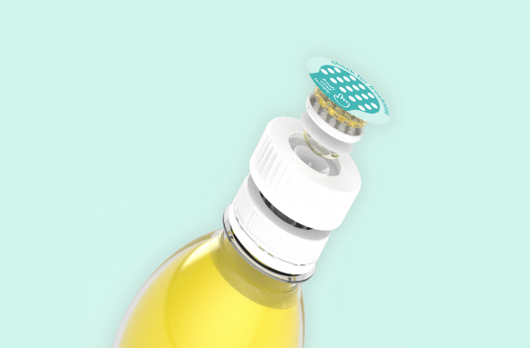
Caption: UNITED CAPS Bump Cap. Image sourced from Mimica
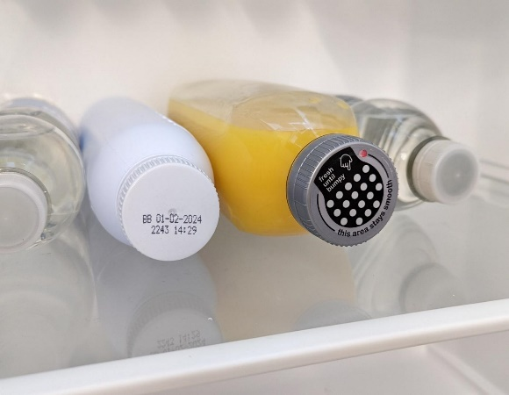
Caption: Using the Bump Cap allows the safe extension of expiry dates from the current overcautious model. The Bump Cap is intuitive and easy to use and requires minimal change on the filling line.

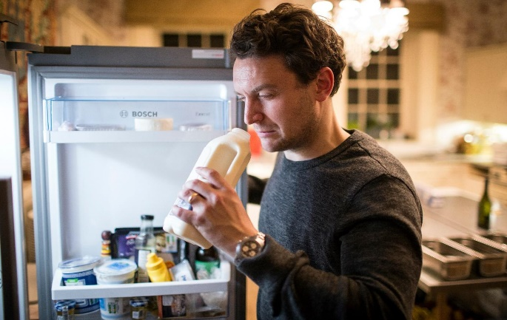
Caption: Prior to Bump Cap, consumers had to smell or taste food to determine its freshness, which was not a foolproof method, often resulting in good food being wasted.
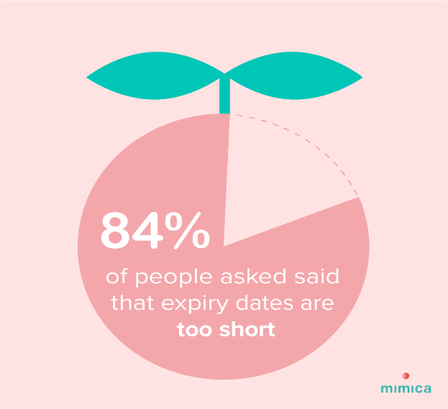

Caption: Brands often set earlier than necessary expiry dates to avoid liability. With Bump Cap, that issue is no longer of concern, and much unnecessary food waste can be avoided.

ABOUT UNITED CAPS
UNITED CAPS is a global industry reference for the design and production of high-performance plastic caps and closures. Extensive innovative capabilities and a broad portfolio of advanced standard and bespoke solutions make UNITED CAPS a preferred partner for the world’s leading companies. We support our customers’ value chain by safeguarding product integrity, assuring safety and consumer health, and ultimately protecting brand reputation. As a highly dynamic and flexible family-based group with an ambitious sustainability agenda, UNITED CAPS offer end-to-end solutions, including mold-making capability, to serve a wide range of applications and markets around the world. The company is headquartered in Luxembourg and has manufacturing facilities in Belgium, France, Germany, Hungary, Ireland, Luxembourg, Malaysia, Spain and the United Kingdom. Employing around 750 people, UNITED CAPS’s turnover amounts to 186 million Euros (as at end 2022) with a 11 billion closures produced.
www.unitedcaps.com

PRESS CONTACT
Monika Dürr
duomedia
monika.d@duomedia.com
+49 (0)6104 944895

