**UFlex introduces new products driven by innovation and sustainability in Q1 FY24**

**Noida, NCR, August 14, 2023:** The research and development and business teams at UFlex Limited continued the momentum of progressive and path-breaking innovations across business verticals in Q1 FY24. The focus on continuous innovation and development has enabled the company to win several awards and patents in the quarter ended June 30, 2023.

**Packaging Films**

1. A white plastic bag on a black surface

   Description automatically generated**High Barrier Alox (F-PSX) Film:** F-PSX is a high-barrier transparent BOPET film. The film has a protective printable layer atop a high barrier vacuum deposit on one side and primer coated or untreated on the other side. The critical attributes of F-PSX include excellent moisture and oxygen barrier properties, higher yield over PVDC coated films, PVDC/EVOH (PE) coated film replacement, environmentally friendly, high clarity, and product visibility. The superior high-barrier application and striking packaging make the film the go-to option for packaging items like dried meat snacks, confectionaries, and other microwavable food items. Other than this, it is also suitable for hot fill, sterilization, pasteurization, report applications (125 degrees C/45 min), and other industrial packaging.

**Chemicals Business**

1. 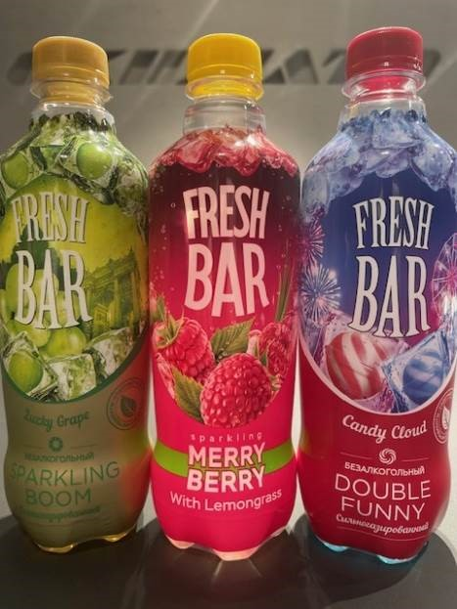**Flex Beam Shrink Sleeve Matt Opaque White:** Flex Beam Shrink Sleeve Matt Opaque White is an electron beam (EB) curable flexo white for shrink sleeves films developed by the UFlex Chemicals business. EB Shrink exhibits high opacity matt finish, tailored adhesion properties, and shrink characteristics that are formulated to print on a variety of shrink films as well as coated papers, films, and label stock on latest generations machines like Comexi Ci8 and other EB Flexo machines. It offers excellent rheology and flexibility with a shrink property of more than 70%. It provides enhanced opacity and adhesion to all types of sleeve material like PVC, PET, PET-G, OPS, OPP, etc.
2. 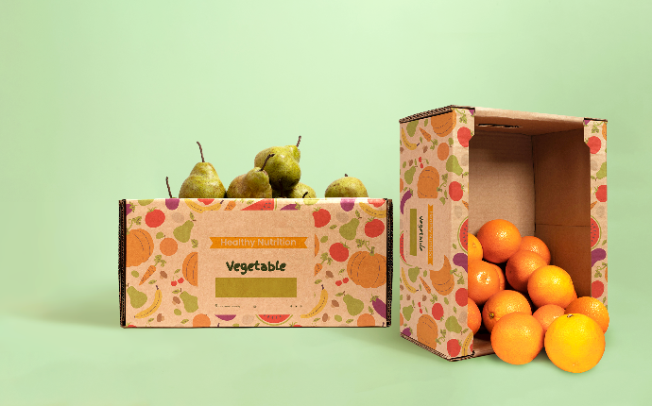**FLEXSEAL HSL OGR (HV):** It is an environment-friendly aqueous dispersion coating by UFlex Chemicals specially designed as oil and grease resistant, heat-sealable coating for paper and paper board applications.  It is suitable for direct food contact applications as per FDA regulations. This product is approved and commercialized for paper board food tray applications.

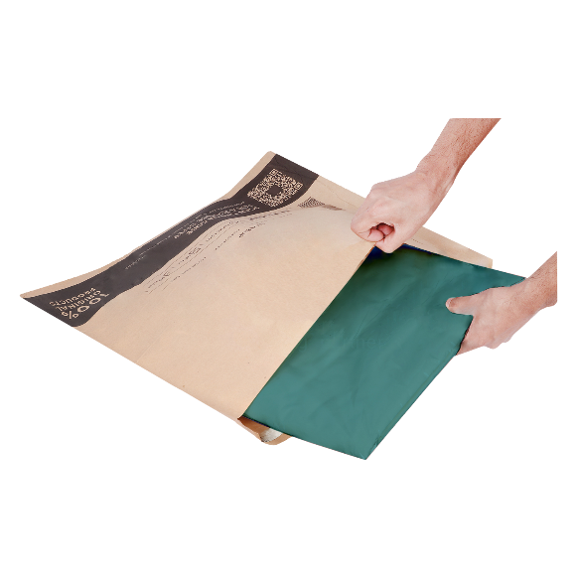

1. **FLEXSEAL HSL 1025(G):** FLEXSEAL HSL 1025(G) is an environment-friendly aqueous dispersion by UFlex Chemicals specially designed as a heat-sealable coating for Kraft papers used in e-commerce paper bag applications. This coating is primarily used on paper for coating-to-coating side sealing on registered areas via the rotogravure process.
2. A package of orange juice

   Description automatically generated**Flexcote HSLV  1170/ HF 200:** Flexcote HSLV 1170/HF 200 is a 2K PU solvent-based adhesive developed by UFlex Chemicals that involves the development of high solids with medium to high-performance for lamination for ketchup, hand wash, and sauce (applications). This product can run at a high solid 45-50%, against the conventional product which runs at 30-35% on a gravure cylinder. Hence, leads to a saving of solvent by 10 – 15%.

**Holography Business**

1. **A close-up of sequins

   Description automatically generatedDhoop-Chaav,** is a cutting-edge, multicolour petrol effect design film developed by UFlex Holography. Designed for decorative applications, this film is specially designed for sequins application in textiles. It imbibes a unique effect where, unlike the typical imported iridescent rainbow films, the Dhoop-Chaav film stands out with its distinctive effect, showcasing a visual appeal that's both captivating and unparalleled. With this new Dhoop-Chhav film, the business is offering an elevated

alternative that will replace imported shimmery rainbow film and take textile designs to greater heights.

**Flexible Packaging Business**

1. 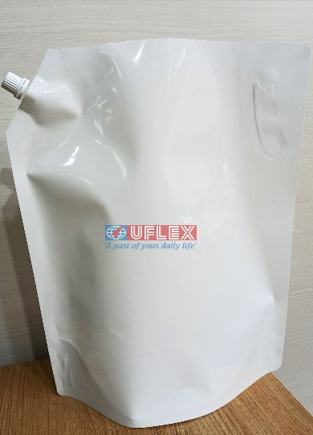**Large format liquid pouches with spout,** developed by UFlex Flexible Packaging, demonstrates technological advancement and material science expertise. Pouch capacity ranges from 3 to 5 litres with innovative, ergonomically suited carry handles, and integrated spouts for enhanced user experience and easy dispensation. This breakthrough packaging is designed to allow at least 70% less usage of plastic material unlike rigids. UFlex portable pouches go through a rigorous testing protocol and thus showcases excellent durability for distribution. It stands out on retail and home shelves with beautiful graphics for applications ranging from beverages to cleaning and laundry liquids. Equally importantly it enables brand owners to make it affordable.
2. **Two bags of food on a table

   Description automatically generated3-D Pouch with slider for 1kg Albikr Alleppey Green Cardamom** is a UFlex developed product that comes with ultra-user-friendly zip closures that provide an assurance of complete fastening and reliable product freshness. The BOPP matt finish film gives a neat and softer look to the packaging, making it look more natural.

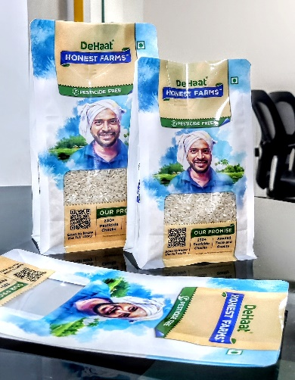

1. **DeHaat 5-paneled pouch for Green Agrevolution** is another product developed by UFlex Flexible Packaging for a startup in Agri space. This is a 5-paneled pouch that is designed with registered tactile coating and a dynamic QR code. These features not only make the packaging stand out but also enable consumer connect.

**Engineering Business**

1. **Rotary Horizontal High-Speed Form Fill and Seal Machine with Gripper:** Over the last decade, the flexible packaging industry has grown to astonishing heights. Among the increasing competition, manufacturers must practice continual innovation and development to stay ahead of the curve. There is a constant need for businesses to evolve to adapt to the needs of customers around the globe. A 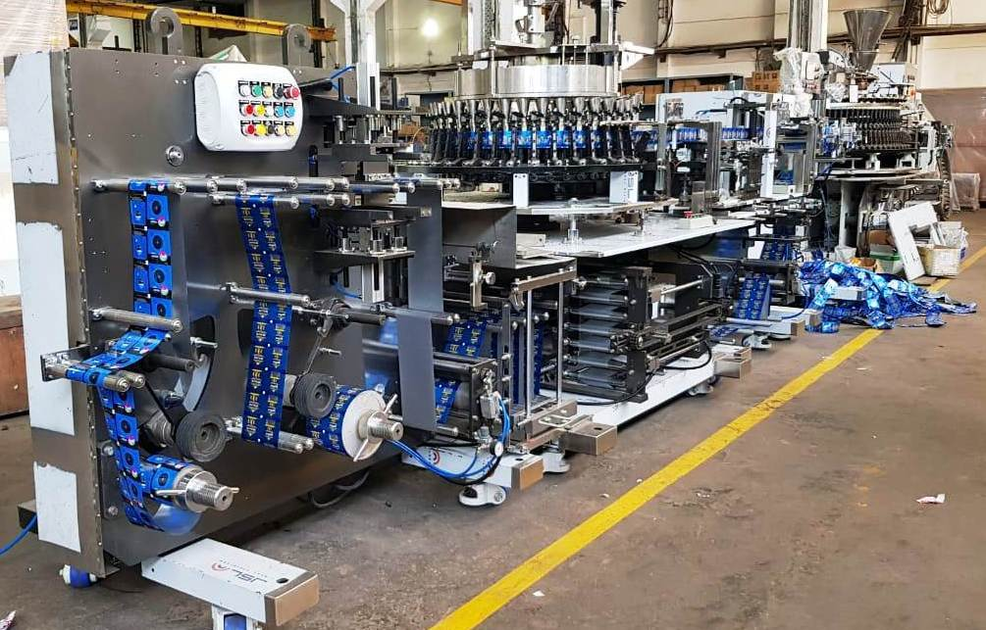revolutionary new design of a Rotary Horizontal High-Speed Form Fill and Seal machine with a gripper by UFlex Engineering enables output pouches to be held into the grippers to make them free from career belts. This ensures the quality of the pouch and controls leaks.

**Awards and Accolades:**

* UFlex was recognized as “**The Economic Times Sustainable Organization 2023”** for its contribution toward sustainable development in the country.
* Flex Films, UAE, has been recognized as “**The** **Economic Times Sustainable Organisation 2023”** for its contribution toward sustainable development in the GCC region.

**Patents:**

* The UFlex Packaging Films business has been granted a patent for its innovative research methodology to develop thermoformable films used for packaging medicines and pharma/edible products **(Patent No.: 431242).**
* The UFlex Engineering business has been granted a patent for a new innovative product, ‘Blister Forming Film from PET’ (**Patent No.: 431432).**

**For media queries, please contact:**

Vidushi Khera | First Partners PR | E: vidushi.khera@firstpartners.in | M: +91 98104 98106

**About UFlex:**

UFlex is India’s largest multinational flexible packaging and solutions company. Since its inception in 1985, UFlex has grown from strength to strength and has built a strong presence across all verticals of the packaging value chain — packaging films, chemicals, aseptic liquid packaging, holography, flexible packaging, printing cylinders, and engineering.

With a 10,000+ strong multicultural workforce across global regions that work toward developing innovative, value-added, and sustainable packaging solutions, the company has earned an irreproachable reputation for defining the contours of the ‘Packaging Industry’ in India and overseas. It provides end-to-end solutions to numerous Fortune 500 clients across various sectors such as FMCG, consumer product

goods, pharmaceuticals, building materials, automobiles, and more, in more than 150 countries. Headquartered in Noida, the National Capital Region, India, UFlex enjoys a global reach with advanced manufacturing facilities in India, UAE, Mexico, Egypt, USA, Poland, Russia, Nigeria, and Hungary.

A winner of various marquee global awards for product excellence, innovation, and sustainability, UFlex is the first company in the world to earn recognition at the Davos Recycle Forum in 1995 for conceptualizing the recycling of mixed plastic waste. For more details, please visit: [www.uflexltd.com](http://www.uflexltd.com)

***