UK retailers choose Greiner Packaging’s sustainable K3® r100 self-separating packaging solution for instant porridge pots

“We are excited to see so many UK retailers realising the benefits of our self-separating packaging solution.”

Seven of the UK’s leading food retailers have changed over to the new K3® r100 self-separating packaging solution from Greiner Packaging UK & Ireland, for their own-brand instant porridge pots.

“Waitrose, Greggs, Morrisons, M&S, Tesco, Lidl and Asda have all moved their successful ready to eat instant porridge brands to our increasingly popular award-winning K3® r100 packaging solution,” says Greiner Packaging UK & Ireland Sustainability and Innovation Manager Rachel Sheldon.

“We are excited to see so many UK retailers realising the benefits of our self-separating packaging solution, following Symington’s which became the first UK food producer to move over to K3® r100 for its Oatburst instant porridge brand last July.”

“The K3® r100 product innovation has made the impossible possible. The cardboard wrap and plastic packaging separate from each other without human intervention during the waste disposal process. This means that achieving a high recyclability rate (up to 98%) does not depend on proper separation by the end consumer – which was the case with all previous K3® packaging – as it now happens completely independently before the used packaging reaches the recycling facility.”

Award winning K3® r100
K3® r100 is the latest evolution of the original K3® cardboard-plastic cup which was invented by Greiner Packaging over 40 years ago. Developed to reduce plastic material usage, K3® features a unique tear-tab so that consumers can intuitively separate the cardboard outer wrap from the lightweight plastic cup to enable recycling.

With the latest development, K3® r100, the materials separate themselves before they reach the near-infrared detection (NIR) system at the recycling facility, leading to proper detection, sorting and recycling. K3® r100 therefore enables cardboard and plastic to be assigned to the correct material streams during the initial sorting process, before being recycled.

In October 2023, Greiner Packaging received the Green Packaging Star Award, from the Austrian magazine KOMPACK, for Berglandmilch being the first company in the country to use the self-separating K3® r100 packaging – and in January 2024, K3® r100 received the World Star Packaging Awards. Last November, Greiner Packaging’s K3® r100 was awarded the Packnews Special Prize within the Packnorth Awards 2024, recognizing outstanding innovation in sustainable packaging.
__

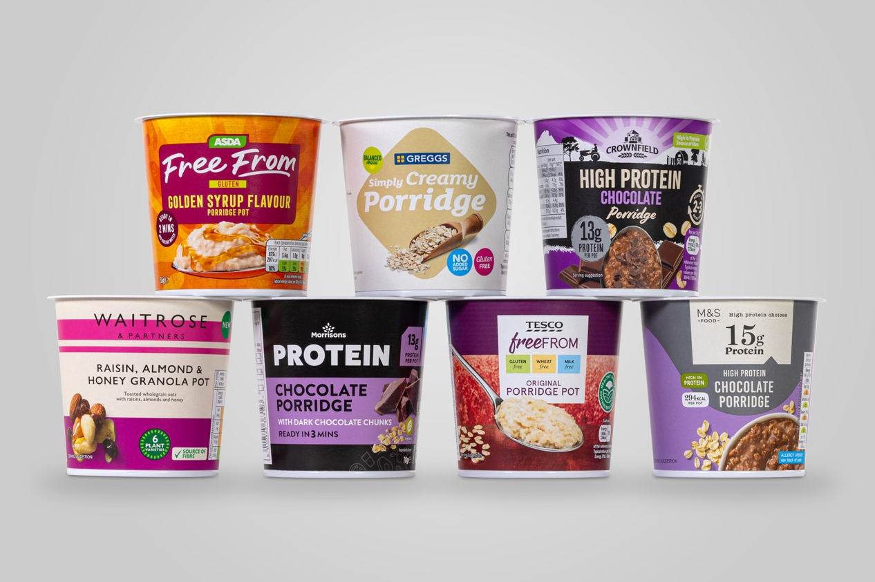

Several UK retailers have adopted Greiner Packaging’s K3® r100 for their own-brand instant porridge pots.

About Greiner Packaging

Greiner Packaging is one of the leading European manufacturers of plastic packaging in the food and non-food sector. For over 60 years, the company has stood for a high level of solution competence in development, design, production, and decoration. Greiner Packaging meets the challenges of the market with two business units: Packaging and Assistec. While the former stands for innovative packaging solutions, the latter focuses on the production of customized technical parts. Greiner Packaging employs more than 4,800 people at 30 locations in 19 countries worldwide. In 2023, the company achieved an annual turnover of 845 million euros (incl. joint ventures). This is almost 40% of Greiner’s total turnover.

Media contact at Greiner Packaging UK & Ireland:
Bill Bruce
Senior Consultant
Bill Bruce Communications
bill@billbrucecommunications.com
+44 (0)7799 347046

More information:
www.greiner-gpi.com

