Announcement
2nd VLB Packaging Conference (VPC)
Online event for the global brewing and beverage industry
August 30 - September 1, 2022
What are the current trends in beer and beverage packaging? What will be next? Further, who drives the marked changes and customer demand? These are some of the questions, that will be discussed on the 2nd VLB Packaging Conference (VPC), taking place from August 30 to September 1, 2022, online at our VLB Virtual Campus – just 2 weeks before the drinktec (12 to 16 September in Munich). Thus, brand owners, brewers and suppliers are invited to get in touch virtually at our conference before meeting face-to-face at the trade fair in Munich.
In three live sessions, following topics will be presented and discussed:
- Session 1: Sustainable packaging solutions for beverages / Returnable systems
- Session 2: Close loop application for packaging materials (rPET, caps, foils etc.)
- Session 3: Efficiency for filling beer and beverages (cans, vegan glue, KPIs etc.)
The (fee-based) live program runs from Tuesday, August 30, until Thursday, September 1. The access to the event platform and to all its content is available from Monday, August 29, 2022, 14:00 (CEST) until Monday, September 5, 2022, 24:00 (CEST).
The event is organized by VLB Berlin and sponsored by Krones and DS Smith.
More information and registration at: https://www.vlb-berlin.org/en/VPC22

About VLB: The Versuchs- und Lehranstalt für Brauerei in Berlin (VLB) is a private members association and was founded in Berlin in 1883 by German brewers and maltsters. For almost 140 years VLB has been working in the field of research, development and training for the brewing and beverage industry – nationally and internationally. Today, round about 130 staff work at the VLB in the fields of research, teaching, information, consulting and service. www.vlb-berlin.org/en
-----
Release date: Berlin, August 9, 2022

Media Contact:
VLB Berlin, Ms Julia Bork, j.bork@vlb-berlin.org

Screenshots from the 1st VLB International Packaging Conference Online, which took place in October 2021

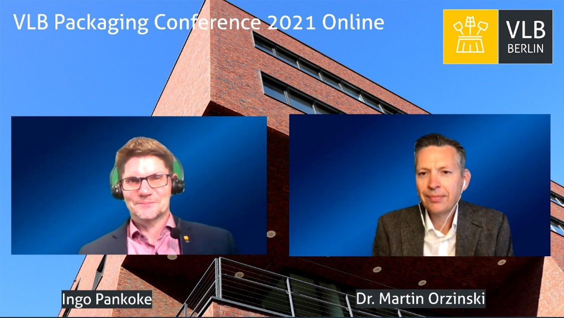

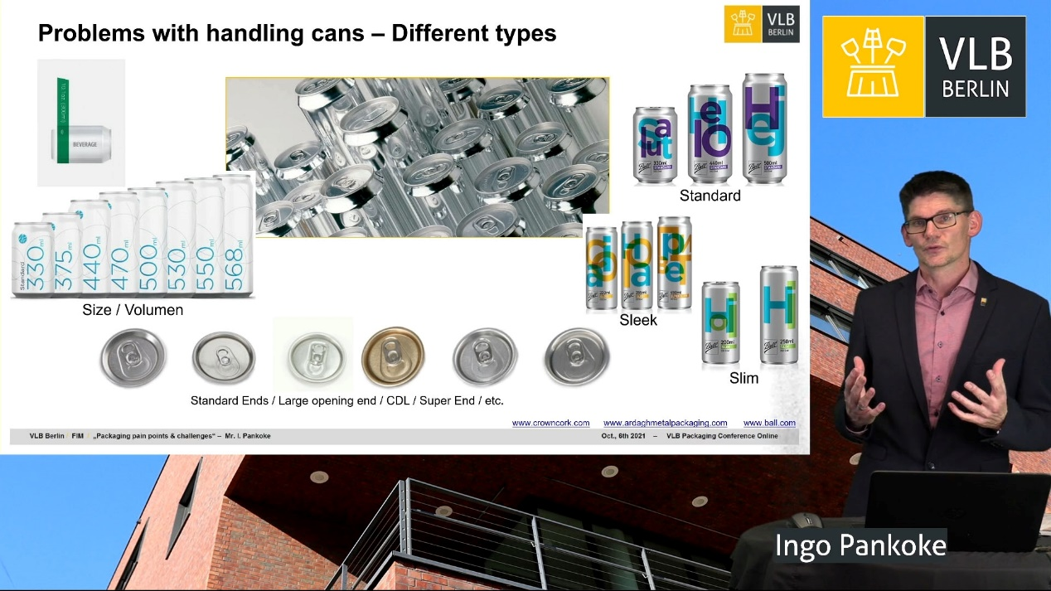

Promo video clip: https://vimeo.com/736426009/719db021b2

