100% performance in 50% of the space
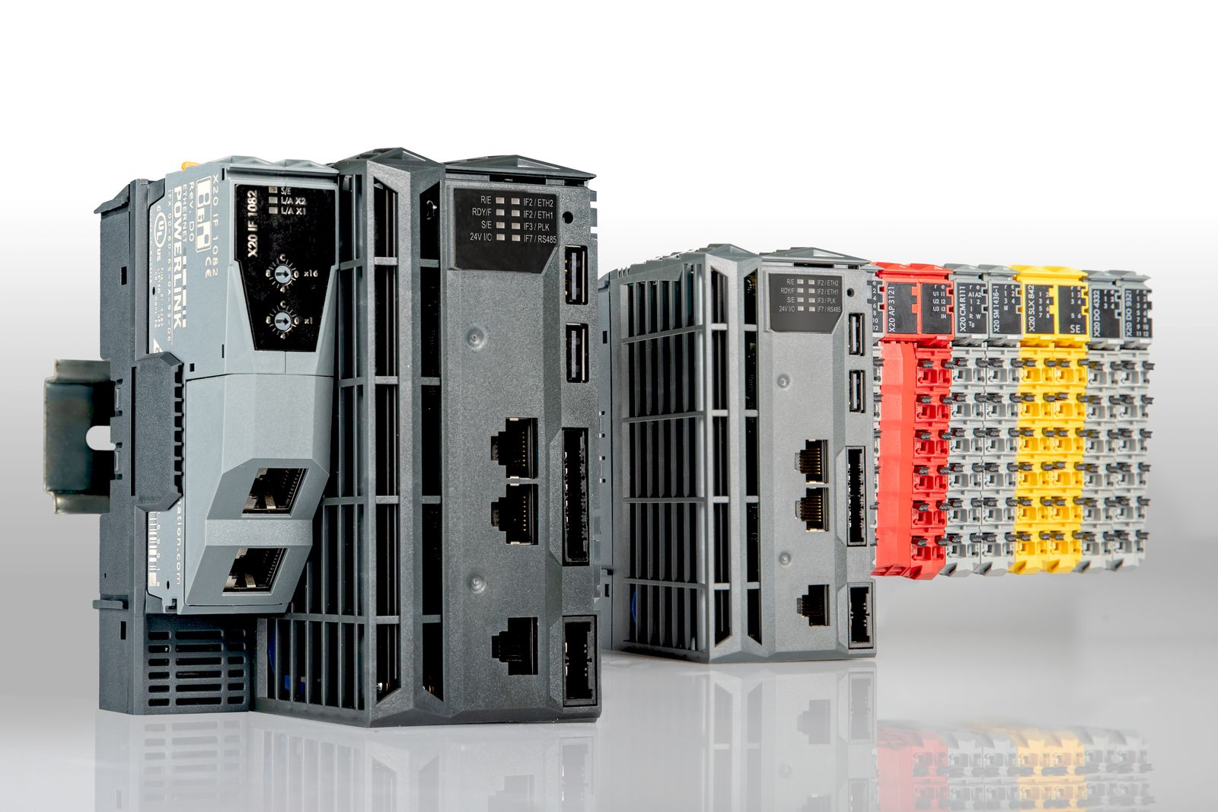
The new X20 Embedded PLC family packs Intel Atom performance into a width of only 55 mm.

B&R's compact new PLC family makes room in the control cabinet
B&R introduces a new PLC family: X20 Embedded. The PLCs combine high performance and numerous integrated interfaces in a housing only 55 mm wide. That makes them only half the width of comparable devices.

With their powerful Intel Atom processors, the new PLCs are also suitable for demanding applications with short cycle times. The compact devices can even control a full-fledged robotics application. Machine builders save both costs and cabinet space.
They come standard with two USB ports, an integrated flash memory card and two Ethernet ports. An integrated switch supports daisy-chain cabling without any additional network infrastructure.

Integrated interfaces
The devices feature hardware interfaces for POWERLINK and RS485. The RS485 interface can be used to connect a frequency inverter directly to the PLC without any additional hardware. The power supply is also integrated. Despite the high performance, the PLCs do not require any fans or batteries, making them fully maintenance free.
Optional variants with an interface slot allow the PLCs to support additional fieldbus protocols. All B&R interface cards can be combined with the X20 Embedded series, and all X20 I/O modules can be connected as usual.

